Starting out Autologging with JTDX

Compiled by Steve VK3VM/VK3SIR

Introduction

This document uses JTDX as an example to start Amateurs on the process of using the “Autologging” facilities that WSJT-X and its derivatives such as JTDX make possible.

By “Autologging” we do not mean that the process is fully automated and one can just walk away and forget. There is software that will do this – but if you are discovered all your logs will be “disavowed” by most of the central logging registries (such as the ARRL with LoTW – Logbook of The World and Clublog)

This is a HUGE area – with this document provided just as an Introduction.

The major “services” will be identified – but how to get access to these services and the costs associated with each service will be your own research task.

Programs Used in this Guide

JTDX is a “Fork” of the WSJT-X v2.2 stream.

It has optimisations that many Amateurs believe make it better for working HF DX.

This will be used as the example application.

The application GridTracker will also be used as it is by far the easiest “Service Connector” app.

Concepts

Basically, the concepts behind “autologging” are:

JT-Ware

This is the generic term for the software based of WSJTX – Developed by Prof. Joe Taylor K1JT. There are 3 main “flavours” (forks) of the project work:

- WSJTX – See https://physics.princeton.edu/pulsar/k1jt/wsjtx.html
- JTDX - A for-HF Optimised version but lacks some facilities – See https://jtdx.tech/en/
- JS8CALL – Uses the basic FT8 Algorithms so one can have a more extended chat rather than just Signal Strength, location and callsign exchanges - http://js8call.com/

In this document JTDX will be described. The current version of WSJTX at the time of writing was Version 2.5.4. JTDX is based off a much earlier “fork” from the WSJT-X project WSJT-X r6462.

JTDX is noted by many HAMs to have distinct advantages over WSJTX when working DX stations. This has been laboratory tested and proven.

Connector Software

The JT-ware has a capability to transfer all data that it has decoded via the Loopback Interface (IP address 127.00.1) at port 2237. This is configurable:

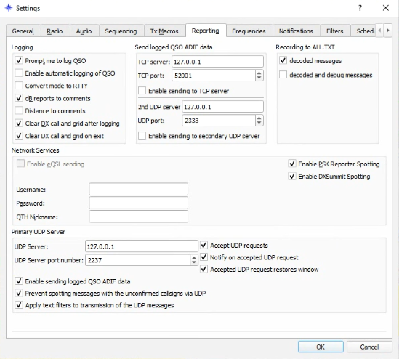

Note the setup inside JTDX (settings are similar with current WSJT-X versions).

JTDX has additional security settings that are not found (yet) on WSJTX that ideally need be set:

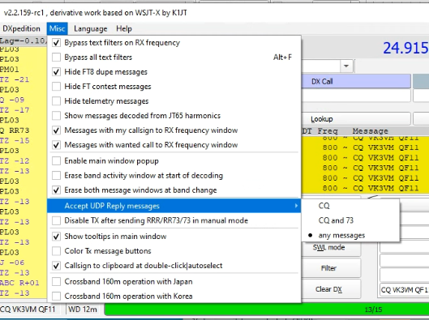

Discussing these basic settings are beyond the scope of this article at this time.

Settings as described should enable a “Connector App” to be set up.

Simplistically, these “Software connectors” read the data and commands sent via the JT-ware package and echo these though the Loopback Interface on Port 2237.

Some software packages can connect directly i.e. DXLab’s DXKeeper.

It is perhaps best to go through a connector package as only one software package can bind to a particular IP address. These connector packages enable such limitations to be overcome.

Common Connector Packages

There are two main connector package sets in use:

- HamApp’s JTAlert – See http://hamapps.com/

- GridTracker – See https://gridtracker.org/

JTAlert is a dedicated connector. It is EXTREMELY COMPREHENSIVE in its functionality and abilities to identify stations. Yet it can be a bit messy for the new user to deploy.

The author of this document uses this package. It will not be discussed further as this is an entry-level guide.

GridTracker has its prime application in displaying Maidenhead Grid Squares and the activity observed between grid squares based on the data received from your JT-ware program.

Almost every 6m op that this author knows uses this app.

GridTracker has a very powerful easily configurable back-end that allows it to do much of what JTAlert does – but without the alleged “bloat” and performance trade-offs.

As this is relatively simple we will document connectivity with this app.

Deploying GridTracker

Firstly ensure that your JT-ware is functioning properly i.e. the way you usually use the software.

Download GridTracker from https://gridtracker.org/downloads/

Read its “Quick Start” at https://docs.google.com/document/d/e/2PACX-1vSa2p38HwIwuQItPtaa42csTtsdzUPXwxoiV3RdHFikr5lqa-Gfd9pG1plsQlC9MNi5N1zj7vOw2DiH/pub

Services that GridTracker will Manage in this Example

DXLab’s DXKeeper

Note that we will assume that you have DXLab’s DxKeeper logging program deployed as your main master system logger. See https://www.dxlabsuite.com/

Any discussion on DXLab and DXKeeper could fill an entire book.

Keep DXKeeper settings basic. Do NOT set it up so that it auto-sends records to LoTW, eQSL and Clublog when a logged record is received. You will need to research how to do this yourself as this is beyond the scope of this introductory document.

LoTW - Logbook Of The World

This is the main “verifier” of contacts and has basically deprecated QSL cards – though it also has manual processes that can be used to handle and manage QSL Cards.

The software can be downloaded at: http://www.arrl.org/tqsl-download .

It is a bit of a pain to set up – and there are two ways for non-Americans to do this:

- One needs to make the certificate application through the TQSL program and then send (not email – send) a copy of a bill in your name to The ARRL in the USA (see http://arrl.org/ ) to get your details verified.

- ARRL Card Checkers (and there are heaps here in Australia now) can perform the same verification task. You make a certificate application through the TQSL program and then contact a ARRL card checker (see http://www.arrl.org/dxcc-card-checker-master-list ) – obviously one near you – and present the same information to them. They can then email the LoTW desk and have your certificate requests validated when received.

If you are serious about working DX then having LoTW is essential to verify contacts.

Discussing LoTW is way beyond the scope of this article.

QRZ.Com Logbook.

A useful version of this facility is available to Amateurs that have an XML Data Subscription to the service (the most basic paid service). See https://shop.qrz.com/collections/subscriptions .

The QRZ.COM logbook is great as it gives near instant access to who you have worked.

It can if set up properly also submit records to LoTW for you. You can also receive records back as well to verify contacts.

Shown below is an example from the configuration page for data that you may need to put into GridTracker from QRZ.COM:

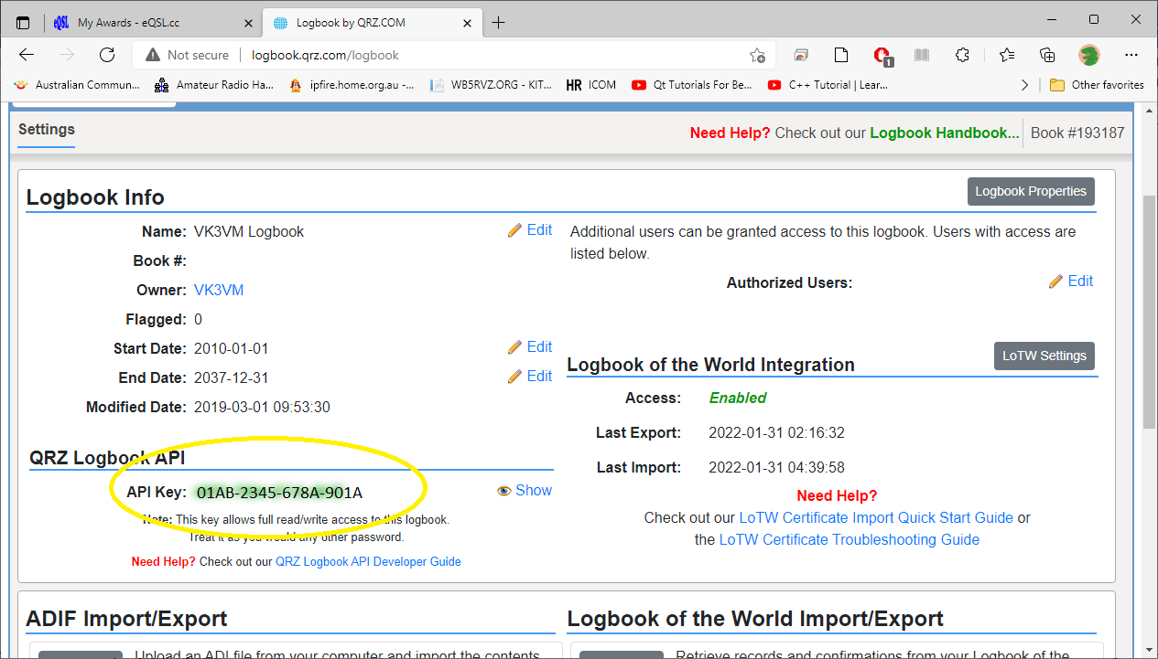

It is this highlighted API Key that is needed to be inserted into GridTracker. Note that this is a dummy key shown as an example and that some information has been redacted from this image.

eQSL

This service found at https://eqsl.cc (not the French “Working Girl” Limousine service found at https://eqsl.com ) is a great HAM-recognised way of exchanging instant QSL cards.

It again is a paid service (see https://www.eqsl.cc/qslcard/faq.cfm ).

GridTracker needs the username, password and if you have moved at any stage the “QTH Nicname”.

ClubLog

Clublog is basically the service used to “verify” how many contacts you have made, on which band, and to which country.

It also maintains “league tables”.

If you want to know if you have made DXCC and or how many contacts you have made on a band then that can be verified through ClubLog.

You pull records in from LoTW and can submit records directly to Clublog.

LoTW is the record Repository. Clublog is basically the validator.

GridTracker needs your username, password and email address for ClubLog.

Configuring GridTracker

Ensure that it is communicating with your JT-ware package first.

- Refer to the earlier “settings” screen from JTDX.

Tune to a frequency where there is some activity:

In GridTracker main interface screen, open “Settings” (Yellow partial-circle)

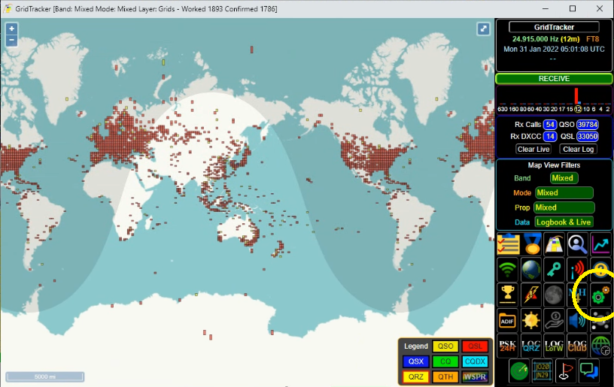

Click on the “General” tab:

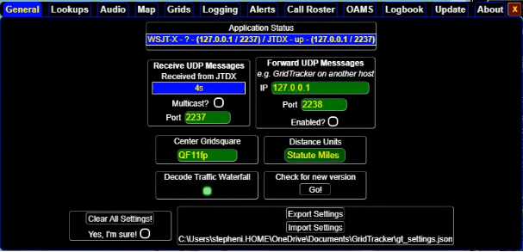

Application Status details display in blue if the application has connected with the JT-ware (i.e. JTDX).

“Receive UDP Messages Received from JTDX” is also blue and ticking over every 15 seconds – each FT8 communication window. This means that the app is communicating properly with JTDX.

It can be quite difficult to get to this point and documenting every step in the event of issues would be voluminous and would still possibly lack a solution for your issue. Seek advice from an expert if it is not working for you.

You can make minor changes i.e. Centre Grid Square and Distance Units (not adjusted here).

Only start other apps such as DXLab DXKeeper after this comms is verified.

Configure GridTracker to talk to other services.

Click in the “Logging” Tab. Enter your own settings using those shown below as a template:

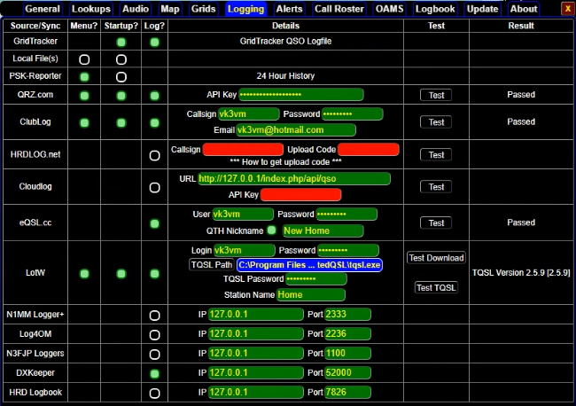
Now its time to start any auxillary applications that will have data sent to them (such as DXKeeper).

Optional Settings

You can also get GridTracker to pull down your logs from LoTW, ClubLog and QRZ.Com Log.

Use the buttons as displayed below:

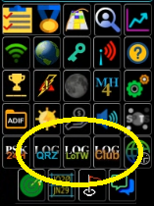

These will take time and will be greyed out until the operation is fully completed. These are the icons in completed mode.

Disclaimer

There will be things forgotten in this basic document.

It can be VERY time consuming to get everything working right.

It is when you try to mix connectors (i.e. GridTracker with JTAlert) that you can really run into issues.

73

© Steve Ireland 2022
VK3VM/VK3SIR
Jan 31 2022.

© Warrnambool & District Amateur Radio Group 2022
Jan 31 2022.

May be reused in part or whole for non-commercial activities as long as original Copyright holders and all sections reused are cited using Harvard Citation Standards.

